**Free Apps for your child to use to practice at home.**

|  |  |
| --- | --- |
| Starfall – practice letters and sounds, holidays and much more. | Starfall - Apps on Google Play |
| English For Kids- Kids Start Learning English |  |
| ABC kids Alphabet Handwriting and Letter Tracing |  |
| 123 Numbers- Count and Tracing |  |
| Sight Words- Bingo |  |

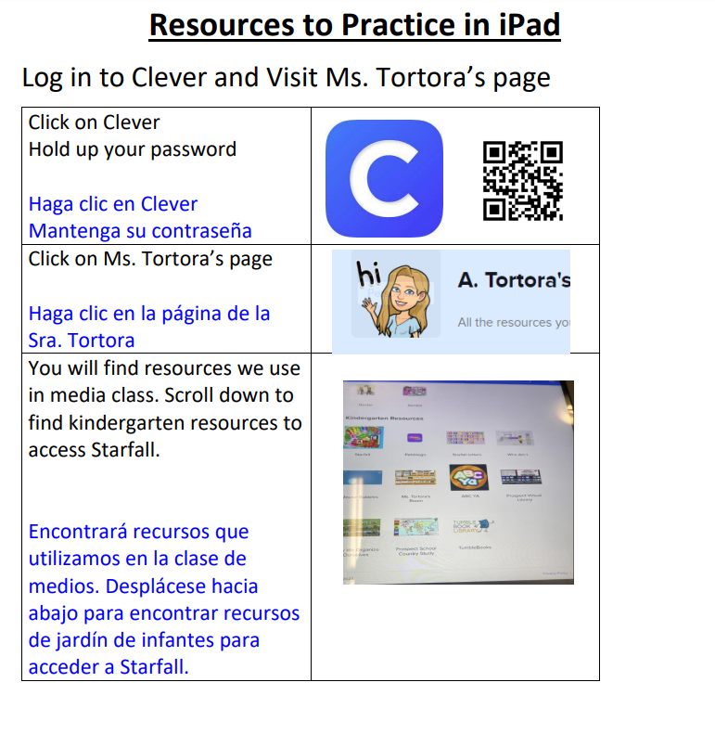

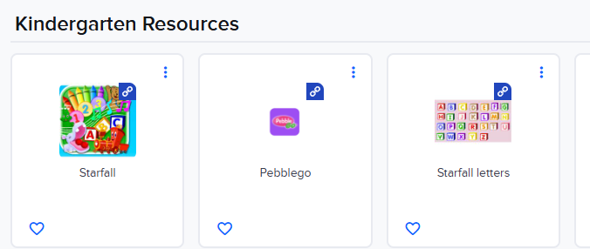

**How to Read e-books on My On- Directions**

|  |  |
| --- | --- |
| Click on Clever  Hold up your password  Haga clic en Clever.  Mantenga su contresana. |  |
| Click on the R for Renaissance  Clic R para Renaissance. |  |
| **Click on MY ON.**  Clic MY ON. |  |

